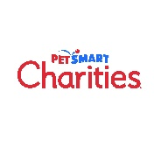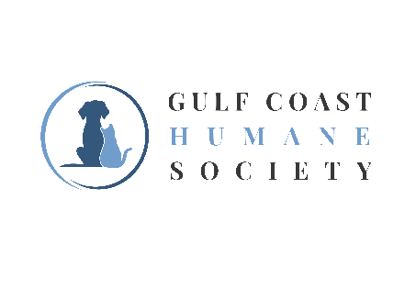

**NEWS RELEASE**  
For Immediate Release

**GULF COAST HUMANE SOCIETY RECEIVES $10,000 GRANT FROM PETSMART CHARITIES TO HELP MORE ADOPTABLE PETS FIND FAMILIES IN THE COASTAL BEND**

**[CORPUS CHRISTI, TEXAS] – [AUGUST 13, 2024]** – Gulf Coast Humane Society has received a $10,000 grant from [PetSmart Charities](http://www.petsmartcharities.org/)**®** to help prepare more pets in the Coastal Bend for adoption. Some four million pets find themselves in U.S. shelters each year. In partnership with PetSmart Charities, Gulf Coast Humane Society will bring adoptable pets to the PetSmart location in Moore Plaza in support of National Adoption Week, taking place **July 15th – 21st .**

“With this grant, we will amplify our efforts to connect fully vetted pets with loving homes swiftly and efficiently while also providing education on proper pet ownership. By expanding our reach beyond Corpus Christi through adoption events and outreach programs, we aim to engage a broader audience and serve more communities.” said Jackie McCollough, director of marketing and development.

“Shelters across the U.S. are struggling to keep pace with the number of animals coming in and need support from their communities to bring pets and people together,” said Heidi Marston, director of pet placement at PetSmart Charities. “We’re proud to support Gulf Coast Humane Society and the essential work they do to care and advocate for the animals that come through their door in need of loving families. Please consider supporting their lifesaving work through volunteering, fostering, adopting, or by donating.”

PetSmart Charities National Adoption Week is a special time during the year. PetSmart stores feature adoptable pets to meet and cuddle in spacious areas, and staff and volunteers are on-hand to make introductions and answer questions. Potential pet parents can also learn about the products and services they’ll need for the best possible start with their new family members.

Members of the community can find more information about Gulf Coast Humane Society’s offsite adoption events as well as view all of their available animals for adoption by visiting their website at gchscc.org

###

**About Gulf Coast Humane Society:**

On January 15, 1945, a group of animal lovers filed a charter to form the Gulf Coast Humane Society for the Prevention of Cruelty to Animals. In April 1998, the Society began operating from its current location, made possible by the generous donation of Tom and Cora Keeler. The Gulf Coast Humane Society rescues thousands of homeless or unwanted pets each year and runs solely on donations. Follow our journey on Facebook, Instagram @gchscorpuschristi

**About PetSmart Charities®**PetSmart Charities is committed to making the world a better place for pets and all who love them. Through its in-store adoption program in all PetSmart® stores across the U.S. and Puerto Rico, PetSmart Charities helps up to 400,000 pets connect with loving families each year. PetSmart Charities also provides grant funding to support organizations that advocate and care for the well-being of all pets and their families. Our grants and efforts connect pets with loving homes through adoption, improve access to affordable veterinary care and support families in times of crisis with access to food, shelter and emergency relief. Each year, millions of generous supporters help pets in need by donating to PetSmart Charities directly at PetSmartCharities.org, while shopping at PetSmart.com, and by using the PIN pads at checkout registers inside PetSmart**®** stores. In turn, PetSmart Charities efficiently uses more than 90 cents of every dollar donated to fulfill its role as the leading funder of animal welfare in North America, granting more than $500 million since its inception in 1994. Independent from PetSmart LLC, PetSmart Charities is a 501(c)(3) organization that has received the Four-Star Rating from Charity Navigator for the past 18 years in a row – placing it among the top one percent of rated charities. To learn more visit [www.petsmartcharities.org](http://www.petsmartcharities.org).

**Follow PetSmart Charities on Instagram:** [@PetSmartCharities](http://www.instagram.com/PetSmartCharities)

**Find PetSmart Charities on Facebook:** [Facebook.com/PetSmartCharities](https://www.facebook.com/PetSmartCharities)  
**See PetSmart Charities on YouTube:** [YouTube.com/PetSmartCharitiesInc](https://www.youtube.com/user/PetSmartCharitiesInc)

**Media Contact:**Jackie McCollough 24-Hour PetSmart Charities  
Director of Marketing and Development Media Line: 623-587-2177  
361-225-0845 ext.104

Fundraising@gchscc.org